Abstract
As the COVID-19 pandemic upended the 2019-20 school year for millions of students, education systems scrambled to meet the needs of students and families, including planning how best to approach instruction during the 2020-21 school year given students may be farther behind than in a typical year. Yet, education leaders have little data on the impacts of school closures on learning. While the COVID-19 learning interruptions are unprecedented in modern times, existing research on the impacts of missing school (due to regular summer breaks, school closures related to weather, and absenteeism) on learning can nonetheless inform projections of potential learning loss due to the pandemic. In this study, we produced a series of projections of COVID-19-related learning loss and its potential effect on test scores in the 2020-21 school year based on (a) estimates from prior literature and (b) analyses of typical summer learning patterns of five million students. Under our COVID Slide projections (which assume that school closures function as an extended summer break), returning students are likely to be starting this fall with approximately 63-68% of the learning gains in reading and 37-50% of the learning gains in mathematics relative to a typical school year. However, we project that losing ground during the school closures was not universal, with the top third of students potentially making gains in reading. Thus, educators likely need to consider ways to support students who are academically behind and further differentiate instruction.

Introduction
Virtually all K-12 students in the United States had face-to-face instruction interrupted during the 2019-20 school year due to the SARS-CoV-2 (COVID-19) pandemic. The majority of school districts provided some remote instruction during the last months of the school year (Lake & Dusseault, 2020a). But it remains unclear how effective remote learning was, given that most K-12 students and teachers had little experience with online instruction and that large gaps in technology access exist in many parts of the country. Additionally, during the extended school closure, many working parents were struggling to educate and care for their children (Harris, 2020). These unique educational challenges were accompanied by broader shocks to society, including a major economic downturn, job losses, widespread protests over racial injustice, and the tangible health threat that is COVID-19. In short, extended time out of school will almost certainly affect student achievement and that impact is hard to estimate given all the unique aspects of COVID-19 on schooling and society.
At the same time, while many aspects of the pandemic make anticipating its impact on achievement difficult, there are parallels between the current situation and other planned and unplanned reasons students miss school that can help us quantify the potential scale of the COVID-19 impact. Specifically, existing research on the effects on learning of (a) summer vacation, (b) weather-related school closures (e.g., Hurricane Katrina in New Orleans), and (c) out-of-school time due to absenteeism can provide a rough sense of how additional time out of school due to COVID-19 might affect achievement in fall 2020 and longer term. The intent of our study is to better understand and project how COVID-19-based school closures might affect achievement and growth during the 2019-20 school year and the 2020-21 school year. Given that our projections, while based on existing literature, are unable to account for the impacts of potential trauma related to COVID-19 (e.g., losing the social supports of school, sick family members, parental job loss, potential homelessness), we present these results as preliminary estimates of the potential negative impacts expected due to extended school closures.
Prior research on time students spend out of school is useful given the importance of forecasting the impact of COVID-19 on short- and long-term achievement. Teachers and schools can benefit from knowing not only how much lower achievement might be when students return in person, but also how much more variable it could be. If students begin school in the fall of 2020 (or whenever regular schooling resumes) with bigger gaps in content knowledge between low- and high-performing students, then strategies like expanding instructional differentiation may be warranted. Further, projections of how potential learning loss due to out-of-school time might affect growth this school year may also help educators identify students who are not on track academically as school resumes and give them needed supports.
In this study, we made projections about the effects of COVID-19 on student achievement trends from the spring of 2020, when schools were first shut down across the United States (U.S.), through to the start of the 2020-21 school year. To provide preliminary estimates of the potential impacts of the extended pause in face-to-face academic instruction during the pandemic, we used a national sample of five million students in Grades 3-8 who took MAP® Growth™ assessments in the 2017-18 and 2018-19 school years (about 22% of the approximately 22 million U.S. public school students in Grades 3-8 according to NCES [2018]). Specifically, we compared typical growth trajectories across a standard-length school year to learning projections that assume students were out of school for the last three months of the 2019-20 school year based on several different scenarios for the effects of that gap in schooling. In so doing, we investigated four research questions:
- What are possible scenarios (based on prior literature and recent MAP Growth data) for student learning patterns during the 2019-20 school year as a result of the school closures?
- How much variability do we expect in (a) students’ learning rates during the extended school closure period and (b) students’ fall 2020 scores assuming a normal 2019-20 school year versus one disrupted by COVID-19?
- What is the predicted association between learning rates during out-of-school time due to COVID-19 and projected subsequent learning rates over the course of the 2020-21 school year?
- Are the COVID school closures projected to impact achievement gaps by school socioeconomic status (SES)?
Background
While the COVID-19 school closures are unprecedented in the U.S., there are multiple bodies of research on which we can draw to anticipate the impacts of extended closures on student learning. These include (a) seasonal learning studies that compare learning that occurs during the school year to learning that occurs during summer breaks, (b) studies on weather-related school closures, and (c) studies on student absenteeism. Table 1 provides a summary of the effect sizes (reported in standard deviation [SD] units for each day out of school) from key studies in each body of literature discussed below (further details on the studies are provided in Appendix A of the online supplemental materials). We then discuss the degrees to which each of these bodies of work is likely to reflect the conditions observed during the COVID-19 school closures.
Studies from seasonal learning studies were mostly descriptive, while the literature on school closure and absenteeism offered a mix of correlational and causal estimates. For the purpose of this study, we consider the research evidence collectively without distinguishing causal estimates from associations and refer to all estimated relations between out-of-school time and achievement as “effects” or “impacts”. We look at both causal and descriptive evidence in tandem because the causal evidence often involves smaller sample sizes and are often less broadly applicable to the current situation.
Seasonal Learning Studies
Seasonal learning research (including studies to understand the effects of summer learning loss) makes comparisons of student learning patterns when school is in versus out of session. Thus, one way to think about COVID-19 school closures is to consider them extensions of summer break for most students. Research has consistently shown that achievement typically slows or declines over the summer months on average and that the declines tend to be steeper for mathematics than for reading (Quinn & Polikoff, 2017). However, there is much debate about the magnitude of summer loss and the degree to which summer vacation contributes to socioeconomic achievement gaps (von Hippel, 2019).
Prominent early work on summer learning loss found that students lost about a month of learning over the summer, with lower-income students falling behind middle- and high-income students in reading (Cooper et al., 1996; Alexander et al., 2001). Recent summer loss research using the Early Childhood Longitudinal Study, Kindergarten Cohort (ECLS-K) has indicated minimal loss on average during the summers following kindergarten and first grade (von Hippel et al., 2018), while studies using NWEA’s MAP Growth assessment showed fairly sizable drops across grade levels (Atteberry & McEachin, 2020; Kuhfeld et al., 2019). This variability in estimates across studies can be seen in Table 1, where summer drop estimates range from 0.001 to 0.010 SDs per day of school missed across grades/subjects. Despite the inconsistencies in magnitude of summer loss, research using both recent data sources are consistent in failing to replicate the earlier finding of summer being the primary period in which socioeconomic inequalities widen (e.g., von Hippel & Hamrock, 2019; Kuhfeld, 2019; von Hippel, 2019). Additionally, both datasets indicate that summer is a particularly variable time for learning, with far higher variability in growth rates during the summer than the school year (Atteberry & McEachin, 2020; von Hippel et al., 2018). (In fact, some students actually show learning gains during the summer.) However, little is currently known about the underlying sources of this variability. Prior research has found gender, racial/ethnic, and socioeconomic characteristics only explain between 3% to 13% of the summer learning variability (Burkam et al., 2004; von Hippel et al., 2018).
School Closures due to Inclement Weather and Natural Disasters
The literature on school closures due to weather or natural disasters also provides some insight into the potential effect of COVID-19 school closures, especially given such closures occur unexpectedly and disrupt scheduled instruction. Although they occur over a shorter duration, school closures resulting from inclement weather or natural disasters provide an analog to school closures due to COVID-19. Absent the weather event or natural disaster, schools would be in session and learning for most students would occur as normal. Hansen (2011) found that each day of school cancellation due to snow in Colorado reduced eighth grade mathematics achievement by magnitudes ranging from 0.013 to 0.039 SDs, and the effects of snow days on student achievement in Maryland ranged from 0.013 to 0.016 SDs per day. Goodman (2014) studied snow day closures in Massachusetts and found that each day of school closure had null effects on mathematics and reading achievement overall, but that students attending schools with a high percentage of students receiving free and reduced-price lunch experienced a decline of 0.014 SDs in mathematics and 0.016 SDs in reading for every day of school closure. Marcotte (2007) and Marcotte and Hemelt (2008) also used data from Maryland to estimate the relations between snowfall and student achievement. However, the measure of achievement was reported as the percentage of students who reached the “proficient” level on the state test, which is not comparable to SDs per day. We include a summary of the results from these studies in Appendix Table A1.
A related line of research found that the displacement effect of Hurricane Katrina led to drops in achievement at a magnitude of approximately 0.10 SDs in the following year (e.g., Sacerdote, 2012). Unfortunately, these studies did not investigate effect heterogeneity by student demographics or school poverty. Further, these estimates are not comparable to those provided by the snow day literature due to differences in research design and recorded units of time.
Absenteeism
In contrast to the seasonal learning and school closure studies discussed above, an emerging literature on school absenteeism focuses on the impact of instructional time loss due to absences while schools are in session. Unlike the school closure due to the COVID-19 that forced every student to be out of school, not all students are absent during a normal school year. There are numerous reasons for which a student might miss school, including lack of access to reliable transportation and need to care for family members. Minority and low-income students tend to have more absences and are more likely to be chronically absent (i.e., missing at least 10% of school days), compared with their more affluent and non-minority peers (Whitney & Liu, 2016).
Research consistently found that absences had negative effects on end-of-year test scores. Several studies that used a value-added type of model found similar effect sizes in both elementary and secondary schools. Specifically, missing ten school days decreased student mathematics test scores by 0.06 to 0.08 SDs, with slightly smaller effect sizes for ELA scores (Aucejo & Romano, 2016; Gershenson et al., 2017; Liu et al., 2019). Largely due to the specific variation used in estimating the impact of absences, studies that used either flu or snow days as an instrumental variable for absences tended to yield much larger estimates (Aucejo & Romano, 2016; Goodman, 2014). For example, Goodman (2014) found that one moderate snow day-induced absence reduced student mathematics scores by 0.05 SDs.
When considering heterogeneity, existing research suggests that absences are similarly harmful for students in different demographic groups, school types, and grade levels. However, two studies have indicated that low-income students suffer more from school absences than their wealthier peers (Aucejo & Romano, 2016; Gershenson et al., 2017). Another takeaway from the absenteeism literature is that the negative effects of absences were linear, meaning that each additional absence caused similar learning loss no matter how many absences a student had already accrued (Gershenson et al., 2017; Liu et al., 2019).
Similarities/Differences Between Out-of-School Time Studies and COVID-19 School Closures
The literatures on summer vacation, school closures due to weather and natural disasters, and absenteeism indicate that student learning is likely to be negatively impacted by being out of school. While there is a fair amount of variability in the effect size estimates by grade and study (Table 1), some clear trends emerge. Students showed bigger losses in mathematics than reading while out of school. Being absent from school is generally associated with larger impacts on learning than being out of school due to summer vacation, particularly in middle school. Finally, our review suggests that studies on summer loss and absenteeism may provide better (if imperfect) models for the impact of COVID-19 than the literature on weather-related school closures, which was sparse (only two studies with effect size estimates), generated inconsistent findings, and tended to rely on small sample sizes from specific geographical settings. Accordingly, we draw on the absenteeism effect sizes reported in Table 1, as well as new summer loss analyses, to produce the projections reported in this study. Before describing our approach, we discuss the unique circumstances of the COVID-19 school closures, including access to virtual instruction and the societal impacts of COVID-19 that go beyond school closures.
Virtual Instruction
One reason past research on school closures may not be an ideal precedent for learning loss due to COVID-19 is that remote learning occurred in many schools during the spring of 2020. Many districts offered remote learning plans, which may include formal curriculum, assignments, progress-monitoring, and access to general educational resources. By early April, 83 percent of parents in a Gallup poll indicated their children were involved in an online learning program from their school (Brenan, 2020). This online instruction could mitigate the losses that students experience during the pandemic.
On the other hand, there is also evidence suggesting that measures taken by schools may not have been as effective as hoped. There are concerning signs that many teachers had no contact at all with a significant portion of students (Lieberman, 2020). According to a national survey of teachers conducted by EdWeek (Kurtz, 2020), as of the first week of April only 39% of teachers reported interacting with their students at least once a day, and most teacher-student communication occurred over email. A survey of district responses collected by the American Enterprise Institute found that only one in five school districts met their standard for “rigorous” remote learning (Malkus, 2020). Nationally, teachers estimated that their students spent half as much time on learning as they were before the COVID school closures (Gewertz, 2020).
Additional evidence shows that even when teachers made themselves and their instructional materials available online, many students lacked the means to access online materials from home. Nearly 50% of low-income families and 42% of families of color lacked sufficient devices at home to access distance learning, according to an Education Trust (2020b) poll. Additionally, high-poverty schools were less likely to report the expectation of providing online learning (particularly synchronous teaching) to all students and reported a higher percentage of students completely absent relative to low-poverty schools (see Table A4 for additional details). Moreover, few school systems provided plans to support students who needed accommodations or other special populations (Lake & Dusseault, 2020b). Thus, despite many administrative leaders’ and educators’ best efforts, students and their families likely bore the brunt of the responsibility for ensuring learning continued during the closures.
There is also uncertainty about whether virtual instruction, even when well-implemented and occurring prior to the pandemic, is as effective as traditional face-to-face instruction. Prior comparisons of online and traditional public schools show mixed results. Most studies found that the impact of attending a virtual charter school was negative, with students in the virtual school performing 0.1 to 0.4 SDs below students in traditional public schools (Gill et al., 2015; Woodworth et al., 2015; Ahn & McEachin, 2017), while in some contexts researchers found null or slightly positive results (Chingos & Schwerdt, 2014). One recent study using data from Florida found positive results for concurrent course performance, yet downstream outcomes, such as passing follow-on courses, that were negative for first-time course takers but positive for those taking courses to recover credits (Hart et al., 2019). These results suggest that different groups of students might respond to virtual learning differently and the results depend on the alternative options students have.
Anticipating the effects of virtual instruction is challenging, even given this body of research evidence, because the conditions within prior research are different from the COVID school closure situation. Extant studies compared the outcomes of students who received similar amounts of online versus traditional face-to-face instruction. By contrast, during the pandemic, students who did not receive online instruction may have gotten no instruction at all. In addition, while certain factors might improve COVID-19 virtual instruction (e.g., students already knew their teachers and were potentially doing review rather than being taught new material), many others make it even harder to achieve effective online instruction, including teachers’ lack of training on virtual instruction generally.
Economic and Related Social Impacts of COVID-19
Finally, past precedent on out-of-school time may understate the impact of COVID-19 on student learning, especially compared to summer break, due to the economic and social impacts of the virus. The same Education Trust (2020b) poll of California and New York parents found that elevated stress levels for families (parents and children) continue due to economic uncertainty and job loss, fears about catching a life-threatening virus, and the psychological impact of social isolation and disruptions to everyday life. The concurrent consequences of the pandemic dramatically affect the health, safety, economic viability, and wellbeing of individuals and communities (Pfefferbaum & North, 2020).
Major economic downturns typically result in a greater number of families experiencing joblessness with higher rates of food insecurity (Wolf & Morrissey, 2017), domestic violence (Schneider et al., 2016; Bowlus & Seitz, 2006), child abuse (Boyer & Halbrook, 2011), and additional social ills. Families also have fewer parental resources during downturns, which can restrict the purchasing ability of essential goods for child development, such as housing, food, and safe and cognitively enriched schooling (Farber, 2015; Kalil & Ziol-Guest 2008). Adult guardians who experience downward occupational mobility can have children with diminished attitudes about the value of work and education. Parental involuntary job loss is also associated with lower self-esteem measures in children and a higher likelihood of grade retention, dropping out, and suspension from school (Johnson et al., 2012; Kalil & Ziol-Guest, 2005, 2008; Stevens & Schaller 2011). Additionally, unemployment is associated with residential mobility that increases family stress and often disrupts children’s schooling and peer networks (Brand, 2015).
Police Shootings and Civil Unrest
In addition to the severe economic downturn created by COVID-19, recent police shootings of African Americans and the ensuing civic unrest likely have created additional turmoil and trauma for Black children. In response to the shootings of George Floyd in Minneapolis and Jacob Blake in Kenosha, protests and demonstrations persisted for many days across the country, some involving violence and clashes with local and federal law enforcement. Prior research shows that such events have negative effects on student achievement in local schools. For example, Gershenson and Hayes (2018) found that the police shooting of Michael Brown in Ferguson and the civic unrest that followed had large, negative effects on the math and reading achievement of elementary schools in the Ferguson area. The detrimental effects of these high-profile police killing incidents are likely more severe and long lasting than what has been documented. Using data from a large urban district in the Southwest, Ang (2020) demonstrated that that police killings, even those that go unreported in the media, caused immediate spikes in absenteeism, decreases in grade point averages, and increased emotional disturbance for high school students who lived close to the site of the events. In addition, these negative effects were greatest for Black and Hispanic students and persisted for several years, as reflected by lower high school graduation and college enrollment rates among students who were 9th graders when the police killings happened. This body of previous research evidence gives us reason to believe that the social unrest resulting from high-profile police shootings and subsequent national protests during spring and summer of 2020 could exacerbate the achievement declines due to COVID-19 school closures by causing additional trauma and stress to students and their families, especially students and families of color.
Summary
The current pandemic is an undeniably unique event with many factors related to student achievement that are hard to quantify, including its direct impact. Nonetheless, given the scale of our data and what we know from past research, we can make plausible forecasts about potential impacts of COVID-19 based on multiple scenarios and assumptions about how learning might have changed during the 2019-20 school year and will change over the 2020-21school year. Even if forecasts can only provide a range of potential impacts based on different assumptions made about the current situation, forecasts are nonetheless valuable in helping educators and policymakers understand what to expect as students return this fall, including how learning might progress differently over the course of the 2020-21 school year.
To that end, our study includes several analyses that can prepare educators and policymakers for what they may face during the 2020-21 school year. First, we contrast projected learning assuming “typical” learning conditions (e.g., if COVID-19 did not happen) with several projections for COVID-19 learning loss during the period students would have otherwise been in school in 2019-20. Our projections are based on summer learning loss estimates from our model and estimates from absenteeism research. Second, we attempt to quantify the effect of school closures on variability in achievement by providing estimates of (a) predicted variability in learning rates during the school closures and (b) predicted variability in student scores at the beginning of the 2020-21 school year that account for the extended time out of school. Third, we look not only at the potential effect on current achievement, but also the relationship between potential learning loss in spring 2020 and growth during the 2020-21 school year (i.e., how strongly associated is the magnitude of learning loss with the gains made in the next year?). Finally, given the reported discrepancies in access to remote learning by school poverty level (Gross & Opalka, 2020; Herold, 2020), we project how the COVID school closures could widen achievement gaps by school-level SES (and discuss why effects on racial/ethnic gaps are especially hard to anticipate).
Methods
Analytic Sample
The data for this study are from NWEA’s anonymized longitudinal student achievement database. School districts use NWEA’s MAP Growth assessments to monitor elementary and secondary students’ reading and mathematics growth throughout the school year, with assessments typically administered in the fall, winter, and spring. We use the test scores of approximately five million third- to seventh-grade students in 18,958 schools across the United States. In this study, we follow students across two school years (2017-18 and 2018-19) and one summer break (summer of 2018). The NWEA data also include demographic information, including student race/ethnicity, gender, and age at assessment, though student-level SES is not available.
Table 2 provides descriptive statistics for the sample by subject and grade. Overall, the sample is 51% male, 47% White, 17% Black, 4% Asian, and 18% Hispanic. School-level free or reduced priced lunch (FRPL) eligibility was obtained from the 2017-18 Common Core of Data (CCD) file from the National Center of Education Statistics (NCES). The average student in our sample attends a school that is 51% FRPL-eligible. A comparison of the 18,972 schools in our sample relative to U.S. population of public elementary and middle schools (72,075 schools serving Grades 3-8) is provided in Appendix B of the online supplemental materials. Overall, the sample closely aligns to the characteristics of U.S. public schools, with a slight overrepresentation of Black students and underrepresentation of Hispanic students.
Measures of Achievement
Student test scores from NWEA’s MAP Growth reading and mathematics assessments were used in this study. MAP Growth is a computer adaptive test that precisely measures achievement even for students above or below grade level and is vertically scaled to allow for the estimation of gains across time. The MAP Growth assessments are typically administered three times a year (fall, winter, and spring) and are aligned to state content standards. Test scores are reported on the RIT (Rasch unIT) scale, which is a linear transformation of the logit scale units from the Rasch item response theory model.
RQ1. Possible Scenarios for Learning Gains during the 2019-20 School Year
To answer this question, we made several projections of the effect of COVID- school closures on learning, each making a different assumption about what prior out-of-school literature should be the basis for the projection. These scenarios, from best-case to worst-case, are:
- Typical Growth. Students learned as in a typical year with no effect from COVID-19. This scenario is used as a baseline for comparison with the other three scenarios.
- Partial Absenteeism. Student learning during COVID-19 closure was assumed comparable to being absent 50% of the time under normal conditions. This scenario stems from teacher reports that students on average received half of the instruction they would normally receive while schools were closed (Gewertz, 2020).
- COVID Slide. School closures were assumed to be equivalent to starting the summer break in March and approximated by typical summer learning loss rates.
- Full Absenteeism. School closures were equivalent to students being absent 100% of the time under normal conditions. This scenario is similar in its assumption to the COVID Slide scenario, but calculated based on learning rates from the absenteeism literature.
Learning rates under Typical Growth and COVID Slide were estimated using multilevel growth models that were fit separately by grade/subject with the MAP Growth assessment data. All technical detail behind these projections is provided in Appendix C. The COVID Slide scenario assumed that typical summer loss patterns would extend through the prolonged school closure. Given the majority of schools in the U.S. shut down around the week of March 15th, 2020 (6.5 months into the school year), we used students’ projected achievement level at 6.5 months as the starting point for the projection and then assumed students lost ground from that point at the monthly rate calculated for each subject/grade. Linear projections were made based on estimated summer learning loss rates but starting from the projected achievement level at 6.5 months and extending to the presumed start of the next school year (12 months, September 1st, 2020).
Under the Partial Absenteeism scenario, we assumed that students received remote instruction, but the exposure to instruction during the school closures was approximately half of what students typically receive if schools were open for face-to-face instruction. This assumption is based on teachers’ reports on the challenges of providing instructional remotely during the COVID school closures (Gewertz, 2020). Under this 50% scenario, COVID-related learning loss is based on loss due to absenteeism rather than loss due to summer slide. This decision was made because absenteeism can occur intermittently amidst days of instruction (as in the scenario described by Gewertz [2020]), whereas summer loss is defined by the complete absence of all schooling for an extended period of time. To make these projections, we drew on existing absenteeism literature. We first calculated an average effect size (in SD units) for each school day missed by subject based on the effect sizes from absenteeism studies reported in Table 1 (e.g., an average of -0.007 SDs per day in mathematics and -0.004 SDs per day in reading). Next we converted these estimates into monthly losses on the RIT scale using NWEA’s subject- and grade-specific achievement norms (Thum & Kuhfeld, 2020), assuming there were approximately 20 potential instructional days in a typical month and that students were receiving approximately 50% of normal instruction (e.g., absent half of the time) due to COVID school closures. Because students can only be absent while schools are still in session, we produced absenteeism projections only to the end of the school year (9.5 months) and then assumed typical summer learning loss in the subsequent 2.5 months. Finally, the Full Absenteeism projection was calculated in the same manner as the Partial Absenteeism projection, but assuming students were absent the full 20 instructional days each month.
To display the possible scenarios for learning as a result of the school closures during the 2019-20 school year, we produced a set of plots to compare these empirical- and literature-based projections to typical learning rates. The plots display students’ estimated learning rates across the 2019-20 school year and summer of 2020 based on the various projections. In addition to the plots, we also reported the impact of school closures as a percentage of learning gains that students were expected to make relative to a typical school year. These percentages were calculated by estimating the total gains during the school year (subtracting the initial score on September 1st, 2019 from the projected score on June 15th, 2020) under the three COVID scenarios and dividing those estimates by the total gains expected under typical growth.
RQ2. Quantifying Variability in COVID-19 Impacts
We do not expect all students to be impacted by COVID-19 school closures equally. Prior summer learning loss research indicated that there is a considerable variability in students’ learning patterns over the summer (e.g., Atteberry & McEachin, 2020; Kuhfeld et al., 2019), most of which cannot be explained by observed student and family characteristics (von Hippel et al., 2019; Kuhfeld, 2019; Borman et al., 2005). In addition to producing average estimates of learning rates during time out of school, we estimated variation across students in: (a) out-of-school (summer) learning rates, and (b) projected student test scores as schools reopen this fall under both typical and COVID Slide conditions (see Appendix C for more details). The Partial/Full Absenteeism scenarios were based on effect sizes from previous studies, and we do not have student-level data to explore variation in absenteeism rates across students. As a result, the variation across students in projected learning rates in this study is only examined for the COVID Slide projections (based on the MAP Growth summer estimates).
RQ3. Estimating the Relationship Between Summer Loss and Next School Year’s Growth
To guide planning to support student learning during this pandemic and school closures, it is important to understand not only the possible impact of school closures on student learning, but also whether students with large losses recover at similar or different rates than other students. To investigate this question, we examined the correlation among the learning rates during the summer of 2018 and in the 2018-19 school year. Though the empirical data are from a typical school year and summer, the results from this analysis can inform decision-making by serving as a proxy for post-COVID-19 student learning recovery during the 2020-21 school year (assuming schools are able to operate normally for the majority of the 2020-21 school year).
RQ4. Achievement Gaps by School SES
Finally, we examined the implications for SES-based achievement gaps using the COVID Slide projections. Since NWEA does not have a student-level indicator of SES, we focused on school-level percentage of students receiving free or reduced priced lunch (FRPL), which was obtained from the 2017-18 Common Core of Data (CCD). We classified low-SES (high poverty) schools as schools with >90% FRPL eligibility and high-SES (low poverty) as those with <10% FRPL eligibility (excluding schools with 10-90% FRPL eligibility). We projected school SES achievement gaps in fall 2020 under three scenarios: (a) all students within each school SES level showed typical learning during the 2019-20 school year, (b) all students within each school SES level showed COVID Slide, and (c) a different percentage of students in low- and high-SES schools showed COVID Slide depending on the likelihood of receiving remote instruction. As described in further detail in Appendix C, the third scenario draws on data collected nationally from an Education Week teacher survey that were disaggregated by school SES. Unfortunately, there was no disaggregation by race/ethnicity. Specifically, the survey found that 73% of high-SES schools reported that all students were expected to receive remote learning during the COVID school closures, compared with only 34% of low-SES schools (Herold, 2020). In our third scenario, we assumed that 73% of the students in the high-SES schools showed typical gains, while the remaining 27% of students were assumed to show COVID Slide. Similarly, in the low-SES schools, we assumed 34% of the students showed typical gains while the remaining 66% of students showed COVID Slide. This third scenario is a mixture distribution reflecting different levels of access to remote learning. Importantly, we assumed that access to remote learning can be approximated based on students’ typical growth rate, which is probably an overstatement given the challenges of remote instruction. In the online supplemental materials, we also consider a fourth scenario that accounts for both differential access to remote instruction and rates of parental unemployment by school SES.
Results
RQ1. Possible Scenarios for Learning Gains during the 2019-20 School Year
Projected COVID-19 impacts on average academic growth trajectories are presented in Figure 1 for mathematics (Panel A) and reading (Panel B). In a typical year, average academic growth is not constant across the academic year (shown as the curved lines seen in some grades) and generally declines from the last day of school through the summer, with steeper declines in mathematics than in reading. The (green) line directly below Typical Growth shows projected trajectories based on the Partial Absenteeism scenario, the subsequent (blue) line shows projected trajectories under the COVID Slide scenario, and the lowest (pink) line within each grade displays the Full Absenteeism scenario. Under each projection, standard summer learning rates (shown as dotted lines) were assumed from the end of the 2019-20 school year to the start of the 2020-21 school year.
Under all of the COVID projections, students’ learning gains were projected to be lower at the end of the 2019-20 school year than under typical conditions. Not surprisingly, the COVID Slide projections were consistently lower than both the Typical Growth and Partial Absenteeism projections, while the Full Absenteeism projections were the most extreme, implying steeper drops while students were out of school across all grades and subjects. We also calculated the percentage of learning gains that students would be expected to have made relative to a normal year under each condition. Our results suggest that in the Partial Absenteeism scenario, students would be expected to begin this school year with 60-87% of their previous year gains (see Table C5 in the online supplemental materials). Under the COVID Slide projections, students were projected to end the abbreviated 2019-20 school year with roughly 63-68% of the learning gains in reading but only 37-50% of the average gains in mathematics compared to a normal school year. Under the Full Absenteeism projections, the story is even more dire, with students in sixth and seventh grade projected to have ended the disrupted 2019-20 school year with less than 30% of their typical learning gains in both mathematics and reading.
RQ2. Quantifying Variability in COVID-19 Impacts
Beyond average achievement, educators may be equally concerned about whether COVID-19 will result in greater variability in the academic skills that students bring with them as school resumes. As seen in Table 3, 8-30% of students in math would be expected to show monthly gains during the summer. In reading, approximately the upper third to half of the distribution (35-45% of students) showed gains over the summer. That is to say, under in a typical summer we observe a large amount of variation in learning patterns, with a sizable proportion of students showing gains in the absence of formal schooling.
Figure 2 displays the predicted variability in fall achievement under COVID-19 relative to variability under a typical school year. The plot shows the predicted interquartile range (e.g., the 25th, 50th, and 75th percentiles) of projected fall 2020 test scores by grade and subject. Additionally, below each set of lines, the ratio of the SD of the projected scores under COVID Slide relative to a typical fall SD is shown for each grade. The estimated means, SDs, and percentiles scores for each condition and grade/subject are reported in Table C6 in the online supplemental materials. Across the board, students are projected to begin this fall with lower scores relative to a typical fall. In math, the predicted SDs are projected to be fairly similar to a typical fall, while in reading, the SDs of expected scores are expected to be up to 1.2 times the SDs expected in a typical fall. Thus, students likely are returning not only with lower achievement (on average), but with a wider range of academic skills that may require teachers to further differentiate instruction.
RQ3. Estimating the Relationship Between Summer Loss and Next School Year’s Growth
To project whether larger COVID-19 learning losses would be associated with faster growth rates during the 2020-21 school year, we examined whether students who lost more ground during a typical summer showed slower or faster rates of recovery during the subsequent typical school year. Correlations between students’ summer loss and linear growth during the 2018-19 school year are presented in Table 3. In mathematics, student-level correlations ranged from -0.41 to -0.43, and in reading, the correlations ranged from -0.45 to -0.46. These correlations imply that students who lost more ground during the summer of 2018 showed steeper growth during the following school year (2018-19) than students with less summer loss. Accordingly, this suggests that a student who lost ground during the summer does not necessarily continue to lose ground during the next school year; rather, they are likely to gain more ground than students who showed modest summer drops.
RQ4. Achievement Gaps by School SES
Finally, we projected whether SES-based achievement gaps were likely to widen under various COVID Slide scenarios. Figure 3 displays the standardized achievement gap between low- and high-SES schools under three scenarios: (a) typical fall, (b) all students within each school SES level showed COVID Slide, and (c) differential access to remote instruction and thereby different combinations of the first two scenarios by school SES level. Our results showed that under typical conditions there were sizable (approximately 0.75 SDs) achievement gaps between low- and high-SES schools across the grades and subjects examined. Perhaps surprisingly, assuming all students showed COVID Slide within each school, SES level did not significantly widen achievement gaps compared to a typical fall. Results from the conditional HLMs (see Table C7) indicated that school SES is not significantly associated with summer learning rates in most subjects/grades, indicating that out-of-school time on its own may not widen achievement gaps. However, our third scenario, which accounted for the fact that students in high-SES schools were more likely to receive remote instruction than students in low-SES schools, resulted in significantly larger achievement gaps in math and slightly larger gaps in reading compared with a typical fall.
Discussion
Educators, policymakers, families, and students find themselves in uncharted territory during the COVID-19 crisis. School districts in particular are on the front lines to help ensure all students have access to academic materials, instruction, and digital resources, among other basic needs such as food for students from low income backgrounds and support for students with disabilities, English learners, and students in temporary housing (Education Trust, 2020a). Despite these efforts, a majority of parents with children in K-12 schools are concerned that their children have fallen behind academically due to the disruptions of COVID-19 school closures (Horowitz, 2020). In this study, we produced a set of possible scenarios for learning loss rates during the extended period when schools were physically closed and students were not receiving normal face-to-face instruction. These projections can help prepare educators and parents for the degree of variability in student achievement to expect as school resumes, and over the course of this school year.
First, we show that, compared to a typical academic year, students will likely (a) not have grown as much during the truncated 2019-20 academic year and (b) will likely lose more of those gains due to extended time out of school. Based on our COVID Slide projections, students who did not receive remote instruction in the spring would begin this fall with approximately 63-68% of the learning gains in reading relative to a typical school year and with 37-50% of the learning gains in mathematics. In some grades, students who did not have access to remote instruction may be starting this school year close to a full year behind in mathematics. Under the Partial Absenteeism scenario, where we assumed that students received approximately half of their typical instruction during the school closures, returning students would begin this fall with approximately 60-87% of their typical learning gains.
Second, we also examined variability in possible learning outcomes during the school closures and in the fall of 2020. We found that losing ground over the summer would not be universal, with the top third of students in reading making gains during a typical summer. As a result of this variability, we projected that the range of students’ academic achievement will be more spread out in the fall of 2020 relative to a normal fall term, particularly in reading. In presenting these projections, we assumed that the variability in typical summer loss can act as a proxy for the variability in learning that is expected during the COVID school closures. In all likelihood, differential access to parent and teacher supports for learning during the school closure months produced greater variability than would be generated in a typical summer break.
Third, although some of the projections are dire, our models also suggest that students who lose the most while out of school would gain the most the following year (at least under typical summer loss conditions). Thus, there is hope that students most impacted by the additional average achievement losses under COVID-19 may also be the ones who rebound the most by the end of the 2020-21 academic school year. At the same time, one cannot be sure how financial uncertainty, health issues related to the virus, and psychological stresses may affect the association between summer loss and subsequent academic growth. Given the on-going health crisis and the fact that many school districts are opening remotely for the fall 2020 semester, it is likely that the 2020-21 school year will not resemble “business as usual”. Therefore, this finding should be taken with an abundance of caution.
Finally, we demonstrated that differential access to technology and remote instruction during the COVID-19 school closures could widen school SES achievement gaps. We found that under the COVID Slide scenario (where all students in both low- and high-SES schools are expected to show COVID Slide), achievement gaps would not significantly differ compared with a typical fall. A likely explanation for this result is that school SES did not appear to be strongly related to summer learning loss in most grades/subjects, so students in low-SES schools were not projected to show substantially larger COVID Slide on average than students in high-SES schools. However, when differential rates of access to instruction by school SES were accounted for in the projections, achievement gaps widened significantly in math and modestly in reading. Results included in the online supplemental materials that accounted for differential likelihoods of exposure to parental unemployment by school SES indicate a more substantial widening of the achievement gap in both math and reading.
Limitations of Our Projections
While we provide three sets of projections in this study—one based on growth rates calculated from MAP Growth data and the other two based on prior literature on student absenteeism—we acknowledge that it is impossible to accurately weigh the complex range of supports and challenges that students are facing during this period. The school closures caused by COVID-19 have additional aspects of trauma to students, loss of resources, and loss of opportunity to learn that go well beyond a traditional summer break or individual school absence for many families. In other words, families with financial resources, stable employment, and flexible work-from-home and childcare arrangements will likely weather this storm more easily than families who are renting their housing, working in low-paying fields that are hardest hit by the economic impacts, and experiencing higher rates of food insecurity, family instability, and other shocks from this disruption. Furthermore, the summer of 2020 was very different from typical summers, with many summer camps and programs closed or online only. As a result, we could be underestimating summer loss between the 2019-20 and 2020-21 school years in our projections by relying on data from a prior summer.
A major limitation of our study is that we do not differentially project the impact of COVID-19 on the basis of race. The COVID-19 pandemic simultaneously occurred alongside social unrest and protests about the mistreatment and killings of Black people by police. Moreover, there are higher rates of unemployment among Black households, and COVID-19 infection and death rates are higher in the Black community than in White communities (Krogstad et al., 2020; Cerullo, 2020). We decided against providing race-based projections due to a fundamental concern that we might understate just how significant the impact of COVID-19 will be on schooling and learning for Black and Brown communities.
There are three primary reasons we worry that projections might understate the effects of COVID-19 for students of color. First, there is very little information at this stage about how COVID-19 is impacting students of color specifically that we could use as the basis for projections. Projecting SES-based gaps is possible because there are at least emergent data on how COVID-19 might differentially affect instruction on the basis of school SES (Herold, 2020). For example, national teacher and principal surveys have provided insights on the rates of synchronous instruction, virtual attendance, technology access disaggregated by school SES (see Table A4). To our knowledge, there is no such national information disaggregated by student race/ethnicity.
Second, projecting race-based gaps would require knowledge on how factors like trauma and job loss would impact racial minority groups differentially. These heterogenous impacts are likely since there are higher rates of COVID-19 infections and deaths in the African American community (Bouie, 2020). Further, the economic downturn has been particularly damaging for Black and Hispanic parents, who are less likely to be able to work from home during the pandemic (Krogstad et al.; Cerullo, 2020). Additionally, the trauma caused by police shootings of African Americans and the subsequent nationwide protests might themselves interact with any COVID-19-induced trauma to impact students’ achievement in complicated ways. Projecting these vital differences by race/ethnicity and their impact on achievement would have involved unwarranted conjecture.
Third, most research on summer loss found that race-based and SES-based achievement gaps do not typically grow much during the summer (Kuhfeld et al., 2019; von Hippel et al., 2018). Thus, an approach of using gaps in summer learning loss as the basis for any additional race- or SES-based projections could understate the effect of COVID-19 on achievement gaps in profound ways given how extended COVID-related school closures may fundamentally differ from typical summers. As von Hippel (2020) has argued, parents with resources are not routinely using those resources to build their children’s math and reading advantage during a typical summer vacation, but during the pandemic those same parents likely were channeling available resources to support student learning through accessing online learning materials, hiring tutors, or forming “learning pods” with other families (Moyer, 2020). This unequal scenario is likely exacerbated by the so-called “digital divide” in technology and internet access by race/ethnicity and socioeconomic status (Musu, 2018), which contributes to greater inequalities during the COVID-19 pandemic than a typical summer.
In short, forecasting is inherently speculative, and we feel that the question of how COVID-19 will affect race-based gaps is too important to speculate on given our current moment, especially since projections would have relied on more assumptions than the other projections in our study and summer loss may be a less appropriate model when examining race-based difference in achievement. When data are available for achievement in fall of 2020, estimating the effect of COVID-19 on those gaps should be a foremost priority.
Another limitation directly related to projections on the basis of race is that our SES-based projections may also be conservative. For example, while Figure 3 shows that achievement gaps on the basis of SES may increase by a third for certain subjects and grades, our projections also indicate that gaps may not widen substantively in other subject-grade combinations. Our school SES projections could very well understate the magnitude of COVID-19’s impact on gaps because our forecasts could not adequately model factors unique to this moment like the trauma associated with illness and sudden job loss (though Figure C2 in the online supplemental materials attempts to factor in additional impacts of parental job loss). Furthermore, we are unable to account for the likely heterogeneity in the impacts of trauma that may lead to increased variability in student learning patterns, which likely implies that our projections are an underestimation of the impacts of COVID on achievement variability. These limitations should be kept in mind as educators and policymakers take actions to address the potential impacts of COVID-19 on U.S. schools and school systems.
Beyond impacts on race and SES, there are also potential technical limitations that bear mention. In calculating the projected impact of out-of-school time on learning in this study, we assumed that it is appropriate to linearly extrapolate learning loss from research on absenteeism and summer loss across the three months of school closure. However, one could plausibly argue that impacts may actually be nonlinear. Campbell and Frey (1970) hypothesize that forgetting learned material may occur non-linearly, with rapid initial deceleration of knowledge followed by slower drop offs as time passes. Liu and colleagues (2019) found that additional absences had an approximately linear impact on student learning, though the number of absences assumed in this study (approximately 60 school days) far exceeds the average number of absences observed in their study. We are unaware of any studies that have examined this phenomenon in the context of summer break. If the true effect of being out of school accelerates the longer students are out of school, we could be underestimating the impact on learning. But if summer loss simply reflects a process of forgetting and re-remembering that is not directly linked to the amount of time out of school, we could be greatly over-estimating the potential impacts on learning. Future research could explore the non-linearity of summer learning using variation in when schools start and end, though given most US public schools follow mostly standard schedules, it is unclear how much variation in the length of summer break exists across school districts.
Where Do We Go from Here?
Our results indicate that students may be substantially behind, especially in mathematics. Thus, teachers of different grade levels may wish to coordinate in order to determine where to start instruction. Educators will also need to find ways to assess students early, either formally or informally, to understand exactly where students are academically. Second, students are likely to enter school with more variability in their academic skills than under normal circumstances. Prior research suggests greater heterogeneity in student achievement affects a classroom teacher’s ability to adapt instruction to meet the instructional needs of all students (Connor, Piasta, Fishman, Glasney, Schatschneider, Crowe, & Morrison, 2009; Evertson, Sanford, & Emmer, 1981). Experts recommend that teaching grade-level content to all students in the fall, while identifying students in need of special support, is likely to help students remain on track (Lynch & Hill, 2020).
Third, under typical schooling conditions, the students who lose the most during the summer tend to gain the most when back in school. Nonetheless, the ground that students have to make up during the 2020-21 academic year will probably be greater due to COVID-19. Therefore, educators may want to work with students to determine growth rates needed to catch up and set learning goals for the year that are ambitious but obtainable. These strategies might include establishing out-of-school learning supports during the 2020-21 school year for the students most affected by school closures.
Finally, the effects of COVID-19 to which our study cannot speak may be ones most worthy of addressing. Districts are rushing to support educators who are attempting to teach academic content remotely while also caring for their students’ social emotional well-being. Prior research on students displaced by Hurricane Katrina indicated that students had difficulty concentrating and often manifested symptoms of depression in the months following the hurricane (Picou & Marshall, 2007). Understanding these impacts will be essential to supporting students’ social and emotional needs after this huge disruption of COVID-19. Many students may face greater food insecurity, loss of family income, loss of family members to the coronavirus, and fear of catching the virus themselves (NAACP, 2020). While the scale of the COVID-19 school closures is novel, the inequalities in our school systems are unfortunately anything but new. Our models cannot account for the reality that the crisis is having an unequal impact on our most underserved communities. Nonetheless, we hope these analyses, which synthesize what we know from existing bodies of research, will inform tomorrow’s decision making.
Strategies for Recovering from COVID Slide
Researchers, district leaders, and policy makers are offering research-based program and policy recommendations designed to make up academic ground from COVID school closures (e.g., Allensworth & Schwartz, 2020; Hill & Loeb, 2020). For example, Kraft and Goldstein (2020) point to High-Dosage Tutoring (HDT) as a promising way to aid schools’ efforts facilitate additional instruction as well as an avenue to stimulate the economy. Several Senate bills seek to expand national service programs such as AmeriCorps (Phillips, 2020). At the state level, former Tennessee Governor Bill Haslam’s Foundation is teaming up with Boys and Girls Clubs and other youth-serving organizations in a pilot program called Tennessee Tutoring Corps which aims to recruit more than 1,000 college students to provide essential employment to recent college graduates who otherwise may be unable to enter the job market. These tutors will offer students in grades K-6 critical one-on-one academic support to help them catch up on content they may have missed due to lost instruction time in the classroom during COVID closures (Blad, 2020; Slavin, 2020).
Given recent state guidance, many school-based summer programs, designed to increase year-round learning opportunities and compensate for typical summer learning loss, pivoted to home-based summer options (Borman, 2020). Such programs have been particularly helpful in boosting reading performance when targeted for low-income (K-8) children (Kim & Quinn, 2013). Home-based summer reading programs (e.g., Kids Read Now, Harvard Graduate School of Education’s READS LAB, etc.) provide students with additional access to reading materials individually matched to interests and student’s reading levels. Moreover, the programs provide parents and teachers guidance to help improve comprehension, employ gentle nudges (e.g., texts, emails, etc.) to encourage continued reading throughout the summer (Borman, 2020). Additionally, free book distribution programs are also a good way to get quality books to underserved families who have access to fewer literacy supports. Various extended learning time interventions, including week-long “acceleration” academies and summer programs, will likely need to be considered to help struggling students during the 2020-21 school year and subsequent summer (Allensworth & Schwartz, 2020).
Finally, research and experts offer strategies to help address students’ emotional needs and that build on teacher-student relationships which will be crucial as districts work through intermittent school closures heading into this academic year. For example, prior research suggests looping, when an educator continues teaching her/his/their current class into the next year, as a promising practice schools may want to scale in 2020-21 (Hill & Jones, 2018). Additional recommendations stress the importance of having teachers work together to uncover missed learning and provide effective responses to trauma in school settings. Using administrative data from online learning platforms, in particular, can equip teachers and support staff with information that can help identify students who have disengaged from instruction and/or who are at risk of dropping out entirely (Hill & Loeb, 2020). For additional recommendations on supporting students’ recovery from the COVID-19 school closures, a series of evidence briefs covering a wide range of topics are available from the EdResearch for Recovery Project (2020).
Conclusions
These preliminary forecasts parallel many education leaders’ fears: missing school for a prolonged period will likely have major impacts on student achievement. Further, students likely are returning this fall with greater variability in their academic skills. Our learning loss projections imply that educators and policymakers will need to prepare for many students to be substantially behind academically as a result of extended school closures, particularly if many schools remain disrupted throughout periods of the 2020-21 school year. Similar to the research that found students took nearly two full years to make up lost ground for the loss in instructional time due to Hurricane Katrina (Harris & Larsen, 2019), our COVID learning loss projections provide new evidence on the scope of the long-term educational recovery efforts that will be required. We believe this study is one in a growing body of important work that leverages prior research to empower school leaders, policy makers, and researchers to make urgent evidence-informed post-COVID-19 recovery decisions.
References
Ahn, J. & McEachin, A. (2017). student enrollment patterns and achievement in Ohio’s online charter schools. Educational Researcher, 46(1), 44–57.
Alexander, K.L., Entwisle, D.R., & Olson, L.S. (2007). Lasting consequences of the summer learning gap. American Sociological Review, 72 (2), 167-180.
Allensworth, E. & Schwartz, N. (2020, June). School practices to address student learning loss. EdResearch for Recovery. Retrieved from https://annenberg.brown.edu/sites/default/files/EdResearch_for_Recovery_Brief_1.pdf.
Ang, D. (Forthcoming). The effects of police violence on inner-city students. Quarterly Journal of Economics. Retrieved from https://scholar.harvard.edu/files/ang/files/PoliceViolence_Ang.pdf.
Atteberry, A. & McEachin, A. (2020). School's out: The role of summers in understanding achievement disparities. (EdWorkingPaper: 20-82). Retrieved from Annenberg Institute at Brown University: https://doi.org/10.26300/2mam-bp02.
Aucejo, E. M. & Romano, T. F. (2016) Assessing the effect of school days and absences on test score performance. Economics of Education Review, 55, 70-87.
Blad, E. (2020, May 12). Former governor recruits stuck-at-home college students to combat K-12's 'COVID slide.' Education Week. https://blogs.edweek.org/edweek/campaign-k-12/2020/05/Haslam-college-tutors-covid-slide.html.
Borman, G. (2020). What can be done to address learning losses due to school closures? The Answer Lab. Center on Education Policy, Equity and Governance. https://theanswerlab.rossier.usc.edu/wp-content/uploads/2020/06/Answer-Lab-COVID-19-Slide-202006-Final-1.pdf.
Bouie, J. (2020). Why Coronavirus is killing African-Americans more than others. New York Times. Retrieved from https://www.nytimes.com/2020/04/14/opinion/coronavirus-racism-african-americans.html.
Bowlus, A. J., & Seitz, S. (2006). Domestic violence, employment, and divorce. International Economic Review, 47(4), 1113-1149.
Boyer, B. A., & Halbrook, A. E. (2011). Advocating for children in care in climate of economic recession: The relationship between poverty and child maltreatment. Northwestern Journal of Law and Social Policy, 6(2), 300-317.
Brand, J. E. (2015). The far-reaching impact of job loss and unemployment. Annual review of sociology, 41.
Brenan, M. (2020, April 8). Over 8 in 10 parents now say child is learning remotely. Gallup. Retrieved from https://news.gallup.com/poll/307754/parents-say-child-learning-remotely.aspx.
Burkam, D. T., Ready, D. D., Lee, V. E., & LoGerfo, L. F. (2004). Social-class differences in summer learning between kindergarten and first grade: Model specification and estimation. Sociology of Education, 77(1), 1-31.
Campbell, D. T., & Frey, P. W. The implications of learning theory for the fade-out of gains from compensatory education. In J. Hellmuth (Ed.), Compensatory education: A national debate, disadvantaged child, vol.3. New York: Brunner/Mazel, 1970.
Cerullo, M. (2020, March 23). Black and Hispanic workers less able to work from home. CBS News. Retrieved from https://www.cbsnews.com/news/work-from-home-black-hispanic-workers/.
Connor, C. M., Piasta, S. B., Fishman, B., Glasney, S., Schatschneider, C., Crowe, E., ... & Morrison, F. J. (2009). Individualizing student instruction precisely: Effects of child by instruction interactions on first graders’ literacy development. Child Development, 80(1), 77.
Cooper, H., Nye, B., Charlton, K., Lindsay, J., & Greathouse, S. (1996). The effects of summer vacation on achievement test scores: A narrative and meta-analytic review. Review of Educational Research, 66 (3), 227-268.
CREDO. (2015). Online charter school study. Stanford, CA: Center for Research on Education Outcomes, Stanford University.
EdResearch for Recovery. (2020). Guiding schools’ COVID-19 recovery decisions using data and evidence. Retrieved July 30, 2020 from https://annenberg.brown.edu/recovery.
Education Trust. (2020a). COVID-19: Impact on education equity: Resources and responses. Retrieved April 18, 2020 from https://edtrust.org/covid-19-impact-on-education-equity-resources-responding/.
Education Trust. (2020b). CA & NY parents overwhelmingly concerned their children are falling behind during school closures. Retrieved April 18, 2020 from https://edtrust.org/ca-ny-parents-overwhelmingly-concerned-their-children-are-falling-behind-during-school-closures/.
Education Week (2020). Map: Coronavirus and school closures. Retrieved from https://www.edweek.org/ew/section/multimedia/map-coronavirus-and-school-closures.html.
Evertson, C. M., Sanford, J. P., & Emmer, E. T. (1981). Effects of class heterogeneity in junior high school. American Education Research Journal, 18, 219-232.
Farber, H. S. (2015). Job loss in the great recession and its aftermath: US evidence from the Displaced Workers Survey (No. w21216). National Bureau of Economic Research.
Gershenson, S., Jacknowitz, A., & Brannegan, A. (2017). Are student absences worth the worry in US primary schools? Education Finance and Policy, 12 (2), 137-165.
Gershenson, S., & Hayes, M. S. (2018). Police shootings, civic unrest and student achievement: evidence from Ferguson. Journal of economic geography, 18(3), 663-685.
Gewertz, C. (2020, May 28). Instruction during COVID-19: Less learning time drives fears of academic erosion. Retrieved from https://www.edweek.org/ew/articles/2020/05/27/instruction-during-covid-19-less-learning-time-drives.html.
Gill, B., Walsh, L., Wulsin, C. S., Matulewicz, H., Grau, E., Lee, A., Kerwin, T., (2015). Inside online charter schools. Cambridge, MA: Mathematic Policy Research.
Goodman, J. (2014). Flaking out: Student absences and snow days as disruptions of instructional time. NBER Working paper 20221.
Gross, B. & Opalka, A. (2020, June). Too Many Schools Leave Learning to Chance During the Pandemic. Center for Reinventing Public Education (CRPE). Retrieved from https://www.crpe.org/sites/default/files/final_national_sample_brief_2020.pdf.
Hansen, B. (2011). School Year Length and Student Performance: Quasi -Experimental Evidence. Social Science Research Networking Paper.
Harris, D. and Larsen, M. (2019). The effects of the New Orleans post-Katrina market-based school reforms on medium-term student outcomes. Education Research Alliance for New Orleans. Retrieved from https://educationresearchalliancenola.org/files/publications/Harris-Larsen-Reform-Effects-2019-08-01.pdf.
Harris, E.A. (2020, April 27). ‘It was just too much’: How remote learning is breaking parents. Retrieved from https://www.nytimes.com/2020/04/27/nyregion/coronavirus-homeschooling-parents.html.
Hart, C. M., Berger, D., Jacob, B., Loeb, S., & Hill, M. (2019). Online learning, offline outcomes: Online course taking and high school student performance. AERA Open, 5(1), 2332858419832852.
Herold, B. (2020, April 1). The disparities in remote learning under coronavirus (in charts). Education Week. Retrieved from https://www.edweek.org/ew/articles/2020/04/10/the-disparities-in-remote-learning-under-coronavirus.html.
Hilger, N. G. (2016). Parental job loss and children's long-term outcomes: evidence from 7 million fathers' layoffs. American Economic Journal: Applied Economics, 8(3), 247-83.
Hill, A. J., & Jones, D. B. (2018). A teacher who knows me: The academic benefits of repeat student-teacher matches. Economics of Education Review, 64, 1-12.
Hill, H. C. and Loeb, S. (2020, May 27). How to contend with pandemic learning loss. Education Week. https://www.edweek.org/ew/articles/2020/05/28/how-to-contend-with-pandemic-learning-loss.html.
Horowitz, J. M. (2020, April 15). Lower-income parents most concerned about their children falling behind amid COVID-19 school closures. Retrieved from https://www.pewresearch.org/fact-tank/2020/04/15/lower-income-parents-most-concerned-about-their-children-falling-behind-amid-covid-19-school-closures/.
Johnson R.C., Kalil A., & Dunifon R.E. (2012). Employment patterns of less-skilled workers: links to children’s behavior and academic progress. Demography, 49, 747–72.
Kalil, A., & Ziol-Guest, K. M. (2008). Parental employment circumstances and children’s academic progress. Social Science Research, 37(2), 500-515.Kim, J. S., & Quinn, D. M. (2013). The effects of summer reading on low-income children’s literacy achievement from kindergarten to grade 8: A meta-analysis of classroom and home interventions. Review of Educational Research, 83(3), 386–431.
Kraft, M. and Goldstein, M. (2020, May 21). Getting tutoring right to reduce COVID-19 learning loss. Brookings Brown Center Chalkboard. https://www.brookings.edu/blog/brown-center-chalkboard/2020/05/21/getting-tutoring-right-to-reduce-covid-19-learning-loss/.
Kuhfeld, M., Condron, D., & Downey, D. (2019). When does inequality grow? A seasonal analysis of racial/ethnic disparities in learning in kindergarten through eighth grade. (The Collaborative for Student Growth at NWEA Working Paper). https://www.nwea.org/resource-library/research/when-does-inequality-grow-3.
Kuhfeld, M. (2019). Surprising new evidence on summer learning loss. Phi Delta Kappan, 101 (1), 25-29.
Kuhfeld, M. & Tarasawa, B. (2020). The COVID-19 slide: What summer learning loss can tell us about the potential impact of school closures on student academic achievement. NWEA.
Kuhfeld, M., & Soland, J. (2020). The learning curve: Revisiting the assumption of linear growth across the school year. (EdWorkingPaper: 20-214). Retrieved from Annenberg Institute at Brown University: https://doi.org/10.26300/bvg0-8g17.
Krogstad, J.M., Gonzalez-Barrera, A. & Noe-Bustamente, L. (2020, April 3). U.S. Latinos among hardest hit by pay cuts, job losses due to Coronavirus. Pew Research Center. Retrieved from https://www.pewresearch.org/fact-tank/2020/04/03/u-s-latinos-among-hardest-hit-by-pay-cuts-job-losses-due-to-coronavirus/.
Kurtz, H. (2020, April 10). National survey tracks impact of coronavirus on schools: 10 key findings. Education Week. Retrieved from https://www.edweek.org/ew/articles/2020/04/10/national-survey-tracks-impact-of-coronavirus-on.html
Lake, R. & Dusseault, B. (2020a). Remote classes are in session for more school districts, but attendance plans are still absent. Center for Reinventing Public Education. Retrieved April 29, 2020, from https://www.crpe.org/thelens/remote-classes-are-session-more-school-districts-attendance-plans-are-still-absent.
Lake, R. & Dusseault, B. (2020b). School systems make a slow transition from the classroom to the cloud. Center for Reinventing Public Education. Retrieved April 18, 2020, from https://www.crpe.org/thelens/school-systems-make-slow-transition-classroom-cloud.
Lake, R. & Olson, L. (2020). Learning as we go: Principles for effective assessment during the COVID-19 pandemic. Center for Reinventing Public Education. Retrieved April 18, 2020, from https://www.crpe.org/sites/default/files/final_diagnostics_brief_2020.pdf.
Levine, P. B. (2011). How does parental unemployment affect children’s educational performance?. Whither opportunity, 315-335.
Lieberman, M. (2020, April 17). Taking attendance during coronavirus closures: Is it even worth it? Retrieved from https://www.edweek.org/ew/articles/2020/04/17/taking-attendance-is-tricky-during-coronavirus-closures.html
Liu, J., Lee, M., & Gershenson, S. (2020). The Short- and Long-Run Impacts of Secondary School Absences. (EdWorkingPaper: 20-125). Retrieved from Annenberg Institute at Brown University: https://doi.org/10.26300/xg6s-z169Q
Lynch, K. & Hill, H. (2020). Broad-based academic supports for all students. Retrieved from Annenberg Institute at Brown University: https://annenberg.brown.edu/sites/default/files/EdResearch_for_Recovery_Brief_6.pdf.
Malkus, N. (2020, June). School districts’ remote-learning plans may widen student achievement gap. Retrieved from https://www.educationnext.org/school-districts-remote-learning-plans-may-widen-student-achievement-gap-only-20-percent-meet-standards/.
Marcotte, D. E. (2007). Schooling and test scores: A mother-natural experiment. Economics of Education Review, 26, 629-640.
Marcotte, D. E., & Hemelt, S. W. (2008). Unscheduled school closings and student performance. Education Finance and Policy, 3(3), 316-338.
Moyer, M.W. (2020, July). Pods, microschools and tutors: Can parents solve the education crisis on their own? Retrieved on August 15, 2020 from https://www.nytimes.com/2020/07/22/parenting/school-pods-coronavirus.html.
Musu, L. (2018, October). The Digital Divide: Differences in Home Internet Access. Retrieved from https://nces.ed.gov/blogs/nces/post/the-digital-divide-differences-in-home-internet-access
NAACP. (2020, March). Ten equity implications of the Coronavirus COVID-19 outbreak in the United States. Retrieved from https://naacp.org/wp-content/uploads/2020/03/Ten-Equity-Considerations-of-the-Coronavirus-COVID-19-Outbreak-in-the-United-States_Version-2.pdf.
National Center for Educational Statistics (2018). Digest of Education Statistics: 2018. Retrieved from https://nces.ed.gov/programs/digest/d18/tables/dt18_203.10.asp.
Pfefferbaum, B., & North, C. S. (2020). Mental health and the Covid-19 pandemic. New England Journal of Medicine.
Phillips, J. (2020, April 28). Using tutors to close the opportunity gap with Matthew Kraft. The Late Bell. https://latebellpod.com/using-tutors-to-close-the-opportunity-gap/.
Picou, J. S., & Marshall, B. K. (2007). Social impacts of Hurricane Katrina on displaced K-12 students and educational institutions in coastal Alabama counties: Some preliminary observations. Sociological Spectrum, 27, 767-780.
Quinn, D., & Polikoff, M. (2017). Summer learning loss: What is it, and what can we do about it. Washington, DC: Brookings Institution. Retrieved from https://www.brookings.edu/research/summer-learning-loss-what-is-it-and-what-can-we-do-about-it/.
Sacerdote, B. (2012). When the saints go marching out: Long-term outcomes for student evacuees from Hurricanes Katrina and Rita. American Economic Journal: Applied Economics, 4(1), 109-135.
Schneider, D., Harknett, K., & McLanahan, S. (2016). Intimate partner violence in the Great Recession. Demography, 53(2), 471-505.
Slavin, R. (2020, May 28). Large-scale tutoring as a solution for school closure losses: Is the idea taking hold? Robert Slavin’s Blog. https://robertslavinsblog.wordpress.com/category/covid/.
Stevens, A. H., & Schaller, J. (2011). Short-run effects of parental job loss on children's academic achievement. Economics of Education Review, 30(2), 289-299.
Thum Y. M., & Kuhfeld, M. (2020). NWEA 2020 MAP Growth Norms for Student and School Achievement Status and Growth. Portland, OR: NWEA.
von Hippel, P. T., & Hamrock, C. (2019). Do test score gaps grow before, during, or between the school years? Measurement artifacts and what we can know in spite of them. Sociological Science, 6, 43–80.
von Hippel, P. T. (2019). Is summer learning loss real? Education Next. Retrieved from https://www.educationnext.org/is-summer-learning-loss-real-how-i-lost-faith-education-research-results/
von Hippel, P. T., Workman, J., & Downey, D. B. (2018). Inequality in reading and math skills forms mainly before kindergarten: A replication, and partial correction, of “Are schools the great equalizer?” Sociology of Education, 91(4), 323-357.
von Hippel, P.T. (2020). How will the coronavirus crisis affect children’s learning? Unequally. Retrieved from https://www.educationnext.org/how-will-coronavirus-crisis-affect-childrens-learning-unequally-covid-19/.
Whitney, C.R. & Liu, J. (2017). What we're missing: A descriptive analysis of part-day absenteeism in secondary school. AERA Open, 3(2), 1-17.
Wolf, S., & Morrissey, T. (2017). Economic instability, food insecurity, and child health in the wake of the Great Recession. Social Service Review, 91(3), 534-570.

Table 1
Estimates of the Impact of Out-of-School Days on Standardized Test Scores Across Summer Loss, School Closure, and Absenteeism Literature
Citation | Location | Grade level | Math Effect | ELA Effect
Summer Loss
Atteberry & McEachin (2020) | National (NWEA) | 1st grade | -0.009 | -0.010
 |  | 2nd grade | -0.006 | -0.006
 |  | 3rd grade | -0.006 | -0.005
 |  | 4th grade | -0.005 | -0.003
 |  | 5th grade | -0.005 | -0.003
 |  | 6th grade | -0.003 | -0.002
 |  | 7th grade | -0.002 | -0.001
von Hippel, Workman, & Downey (2018) | National (ECLS-K:2011) | Kindergarten | 0.002 | -0.001
 |  | 1st grade | -0.001 | -0.001
Kuhfeld, Condron, & Downey (2019) | National (NWEA) | Kindergarten | -0.005 | -0.004
 |  | 1st grade | -0.007 | -0.004
 |  | 3rd grade | -0.006 | -0.004
 |  | 4th grade | -0.005 | -0.003
 |  | 6th grade | -0.004 | -0.002
 |  | 7th grade | -0.002 | -0.001
Absenteeism
Liu, Lee, & Gershenson (2020) | large urban CA school district | 6th-8th grade | -0.008 | -0.006
Gershenson, Jacknowitz, & Brannegan (2017) | ECLS-K + NC | K-1st grade | -0.002 | -0.002
 | NC public schools | 3rd-5th grade | -0.007 | -0.004
Aucejo & Romano (2016) | NC public schools | 3rd-5th grade | -0.006 | -0.003
School Closures due to Inclement Weather
Hansen (2011) | CO and MD public schools | 8th grade (CO) | -0.013 to -0.039 | N/A
 |  | 3rd grade (MD) | -0.003 to -0.011 (NS)
 |  | 5th grade (MD) | -0.015 to -0.016
 |  | 8th grade (MD) | -0.009 to -0.013
Goodman (2014) | MA public schools | 3rd-8th + 10th grade | -0.000 (NS) | 0.003 (NS)
Note. ECLS-K=Early Childhood Longitudinal Study, Kindergarten Cohort, CA=California, NC=North Carolina, CO=Colorado, MD=Maryland, MA=Massachusetts, NS=Not significant. All coefficients are reported as drops in standard deviation units on mathematics and reading/English Language Arts assessments for each day of school missed. More details on each study (as well as studies that were reviewed but excluded from this table) are presented in Appendix Table A1-A3 in the online supplemental materials.
Table 2
Descriptive Statistics for the Sample
 |  |  | Race/ethnicity |  |  |  |  |  | Male | % FRPL
Grade | N. Schools | N. Students | White | Black | Asian | Hispanic | Other race
Mathematics
3 | 12,816 | 986,862 | 0.45 | 0.18 | 0.04 | 0.18 | 0.14 |  | 0.51 | 0.51
4 | 13,071 | 999,788 | 0.46 | 0.17 | 0.04 | 0.18 | 0.14 |  | 0.51 | 0.50
5 | 14,146 | 1,029,363 | 0.47 | 0.17 | 0.05 | 0.18 | 0.13 |  | 0.51 | 0.50
6 | 8,952 | 976,105 | 0.47 | 0.17 | 0.04 | 0.18 | 0.14 |  | 0.51 | 0.50
7 | 7,040 | 937,054 | 0.47 | 0.16 | 0.04 | 0.18 | 0.13 |  | 0.51 | 0.50
Full Sample | 18,972 | 4,929,172 | 0.47 | 0.17 | 0.04 | 0.18 | 0.14 |  | 0.51 | 0.50
Reading
3 | 12,874 | 988,644 | 0.45 | 0.18 | 0.04 | 0.18 | 0.14 |  | 0.51 | 0.51
4 | 13,066 | 997,088 | 0.47 | 0.18 | 0.04 | 0.18 | 0.14 |  | 0.51 | 0.51
5 | 14,129 | 1,026,057 | 0.47 | 0.17 | 0.04 | 0.18 | 0.13 |  | 0.51 | 0.50
6 | 8,943 | 970,524 | 0.47 | 0.17 | 0.04 | 0.18 | 0.14 |  | 0.51 | 0.50
7 | 6,995 | 934,960 | 0.48 | 0.17 | 0.04 | 0.18 | 0.13 |  | 0.51 | 0.50
Full Sample | 18,958 | 4,917,273 | 0.47 | 0.17 | 0.04 | 0.18 | 0.14 |  | 0.51 | 0.50
Note. N=Number, %FRPL=percentage of free or reduced priced lunch. Grade is the grade level students were in during the 2017-18 school year.

Table 3
Variability in Projected Out-of-School Time Learning Rates
Grade | Subject | Monthly Summer Drop | Summer Drop SD | Corr(Summer, Sch Year) | Percentage of Students Show Gains During the Summer |  | Monthly Learning Loss at Different Points in the Distribution
 |  |  |  |  |  |  | 25th Perc. | 50th Perc. | 75th Perc.
3 | Mathematics | -1.35 | 1.98 | -0.42 | 16% |  | -2.68 | -1.35 | -0.01
4 | Mathematics | -1.45 | 2.01 | -0.41 | 15% |  | -2.81 | -1.45 | -0.09
5 | Mathematics | -2.01 | 2.30 | -0.41 | 8% |  | -3.55 | -2.01 | -0.45
6 | Mathematics | -1.04 | 2.17 | -0.42 | 25% |  | -2.51 | -1.04 | 0.42
7 | Mathematics | -0.79 | 2.29 | -0.43 | 30% |  | -2.33 | -0.79 | 0.75
3 | Reading | -0.75 | 2.72 | -0.45 | 35% |  | -2.58 | -0.75 | 1.09
4 | Reading | -0.58 | 2.61 | -0.46 | 37% |  | -2.34 | -0.58 | 1.18
5 | Reading | -0.53 | 2.63 | -0.46 | 38% |  | -2.30 | -0.53 | 1.24
6 | Reading | -0.44 | 2.71 | -0.46 | 42% |  | -2.26 | -0.44 | 1.39
7 | Reading | -0.27 | 2.78 | -0.46 | 45% |  | -2.15 | -0.27 | 1.60
Note. SD=standard deviation; Perc.=percentile. The monthly summer drop, summer drop SD, correlation between summer and subsequent school year, and learning loss at various percentiles were all estimated from the HLM parameters. The percentage of students showing gains were estimated based on the empirical Bayes (EB) estimates.

- Mathematics Projections
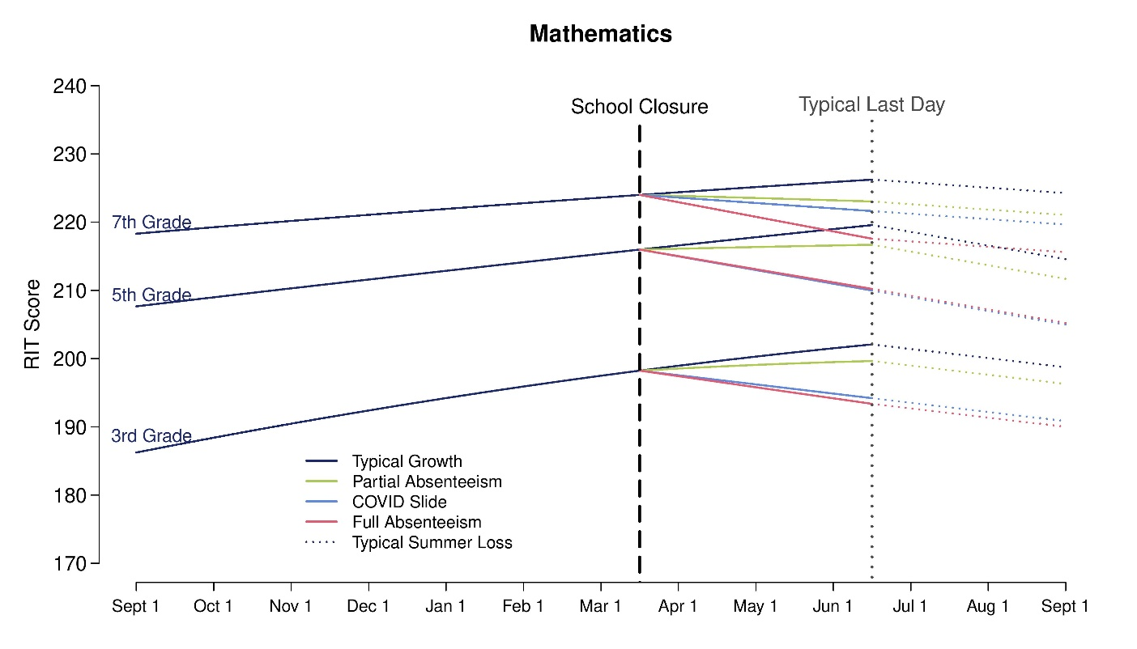

- Reading Projections
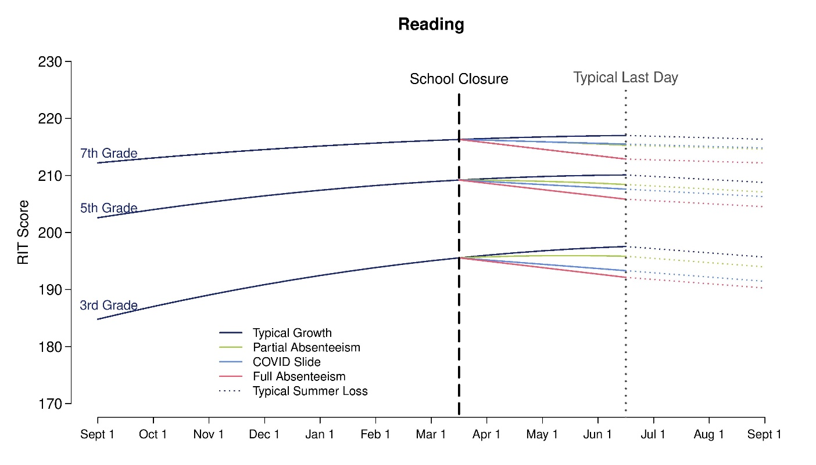
Figure 1. Mathematics and reading forecasts based on typical growth, partial and full absenteeism, and summer loss estimates.
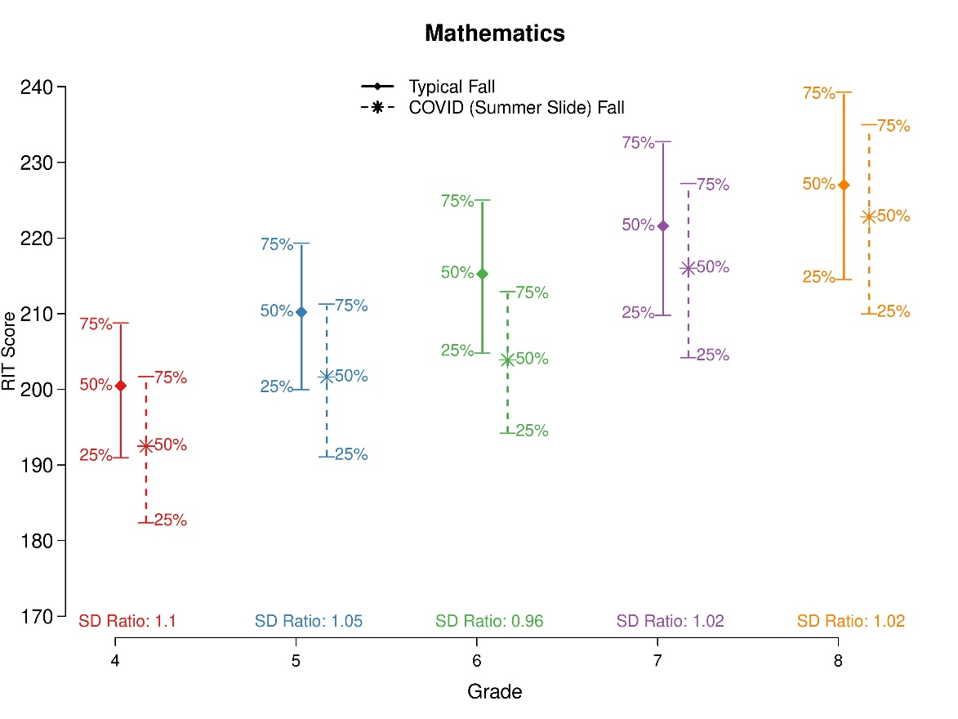
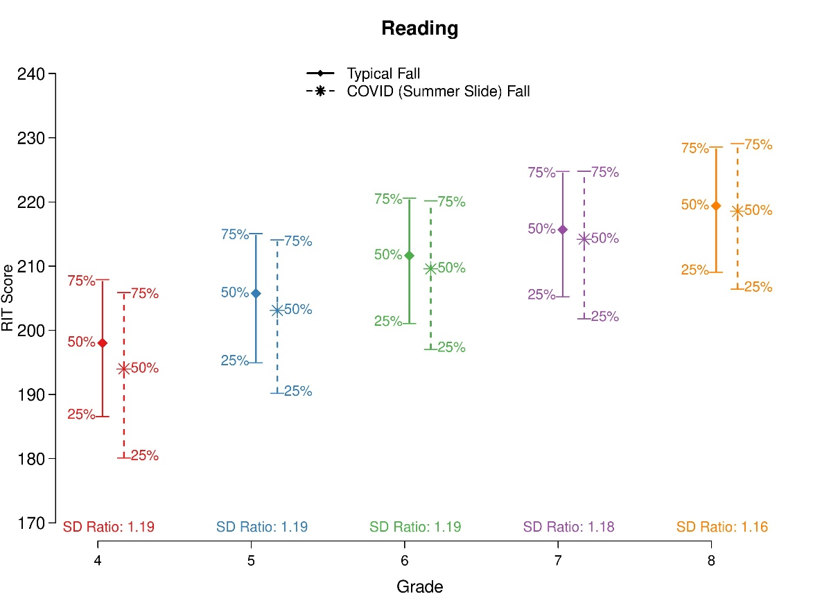
Figure 2. Projected fall 2020 score distributions under a typical fall (fall 2018) and COVID Slide conditions. The SD ratios display the estimated SD under COVID Slide divided by the estimated SD in a typical fall.
- Achievement Gaps in Mathematics Between Low-High SES Schools
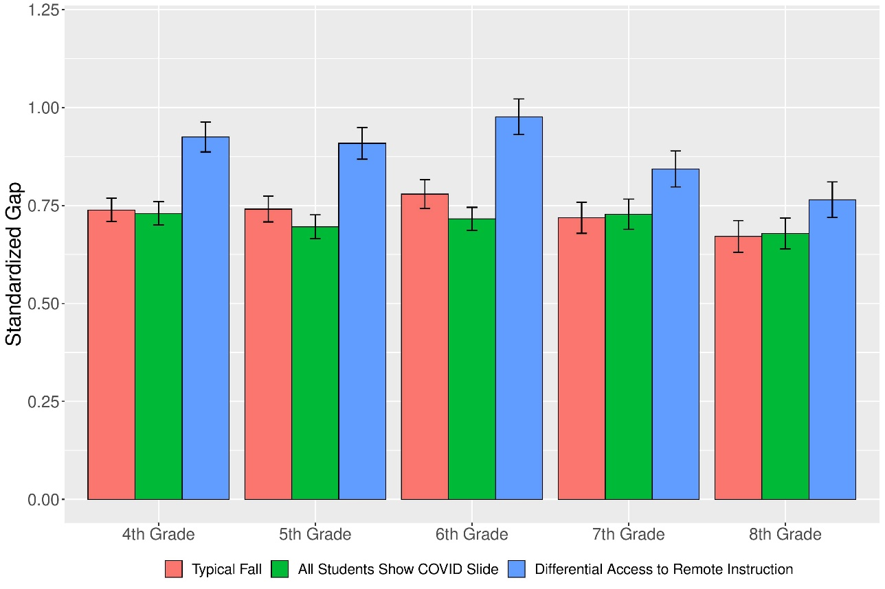

- Achievement Gaps in Reading Between Low-High SES Schools
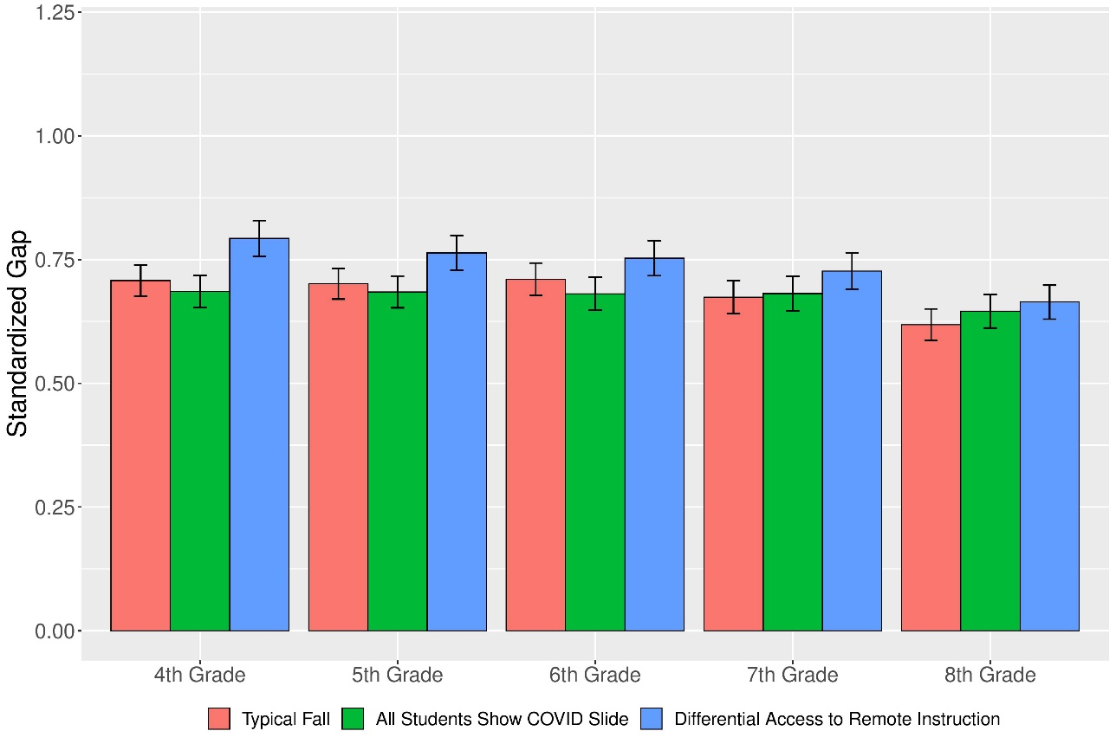
Figure 3. Standardized achievement gaps between low-SES (>90% FRPL) and high-SES (<10% FRPL) schools under three projected scenarios

This paper has its origins in a NWEA brief (Kuhfeld & Tarasawa, 2020), which presents some preliminary learning projections. The current paper is distinct from the brief in terms of the volume of analyses and theoretical grounding.
Due to limited MAP Growth testing in high schools, we did not follow the cohort of 8th graders in 2017-18 into 9th grade in 2018-19.
In Appendix C in the online supplemental materials, we consider a further worst-case scenario that assumes full absenteeism plus the additional impact of exposure to trauma during the school closure period. However, given the speculative nature of this scenario, we have chosen to leave it out of the main findings.
For a review of diagnostic assessment recommendations and their role in helping educators and parents support student learning, see Lake and Olson (2020).

